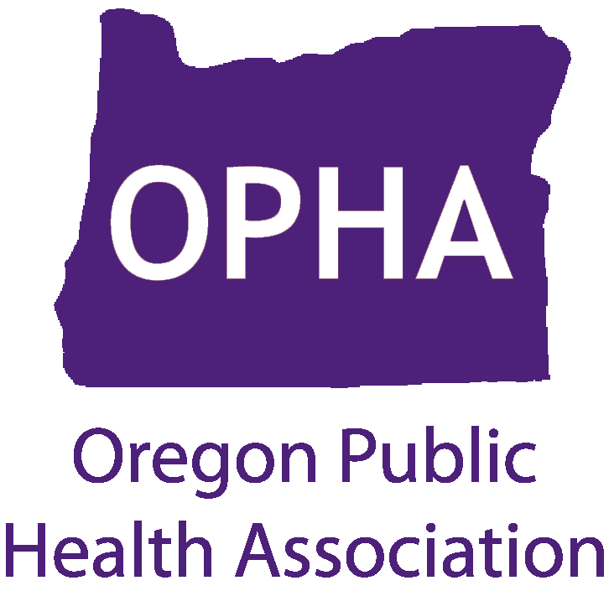

Oregon Public Health Week

Dates: April 6 – 12, 2015
Location: All over Oregon

Join the Oregon Public Health Association as we celebrate National Public Health Week, the first full week of April every year. OPHA joins the American Public Health Association in championing the health of all people and communities. OPHA is hosting the statewide event calendar on our website. For details and to submit an event, visit:

http://www.oregonpublichealth.org/public-health-week

