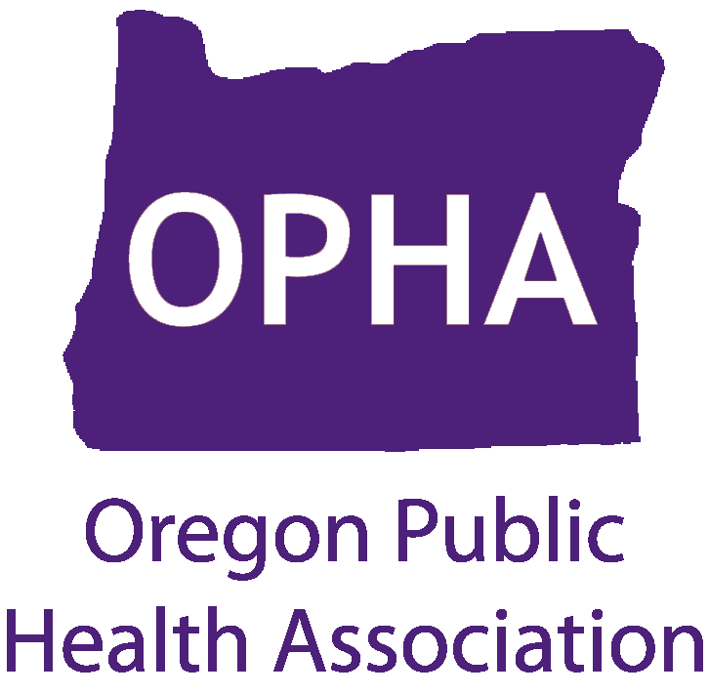
Open Heart, Mind, Soul, and I am Whole: Conversations about Sexuality and Dis/ability
Presentation & Discussion
Date: Tuesday, May 19th 2015

Time: 12:00pm-3:00pm
- Lunch will be provided at 12:00pm
- Presentation begins at 12:30pm

Location: Kaiser Town Hall Venue
3704 N Interstate Ave
Portland, OR 97227

This event is approved for two Free Category I CHES Credits.

To register for this free event visit:
http://www.oregonpublichealth.org/events.

