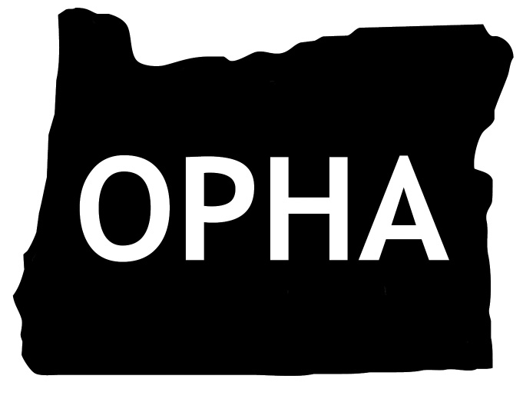
OPHA 78th Annual Meeting and Conference
2022 Program

Monday, October 17, 2022

8:00 – 9:00 Registration & Continental Breakfast

9:00 – 9:15 Welcome & Opening Remarks
Tabitha Jensen, MBA
President, Oregon Public Health Association

9:15 – 10:15 Keynote Address

10:15 – 10:30 BREAK

10:30 – 11:45 Concurrent Sessions #1

11:45 – 12:00 Pick up Boxed Lunches

12:00 – 1:00 Lunch & Networking
Section Meetings

1:00 – 1:15 BREAK

1:15 – 2:15 Keynote Address

2:15 – 2:30 BREAK

2:30 – 3:45 Concurrent Sessions #2

2:30 – 3:45 ***OPHA Board Meeting***

3:45 – 5:15 OPHA Poster Session
Networking & Reception

----End of Day One----

OPHA 78th Annual Meeting and Conference
2022 Program

Tuesday, October 18, 2022

8:00 – 8:30 Registration & Continental Breakfast

8:30 – 8:45 Welcome & Introductory Comments
Phyusin Myint, PhD
President-Elect, Oregon Public Health Association

8:45 – 9:00 Brief reports from OPHA Sections

9:00 – 10:00 Keynote Address

10:00 – 10:15 BREAK

10:15 – 11:30 Concurrent Sessions #3

11:30 – 11:45 BREAK
Lunch buffet

11:45 – 1:00 OPHA Awards Luncheon, Annual Membership & Business Meeting

1:00 – 1:15 BREAK

1:15 – 2:15 Keynote Address

2:15 – 2:30 BREAK

2:30 – 3:45 Concurrent Sessions #4

3:45 – 4:00 BREAK

4:00 – 5:15 Concurrent Sessions #5

----Conference Conclusion----

