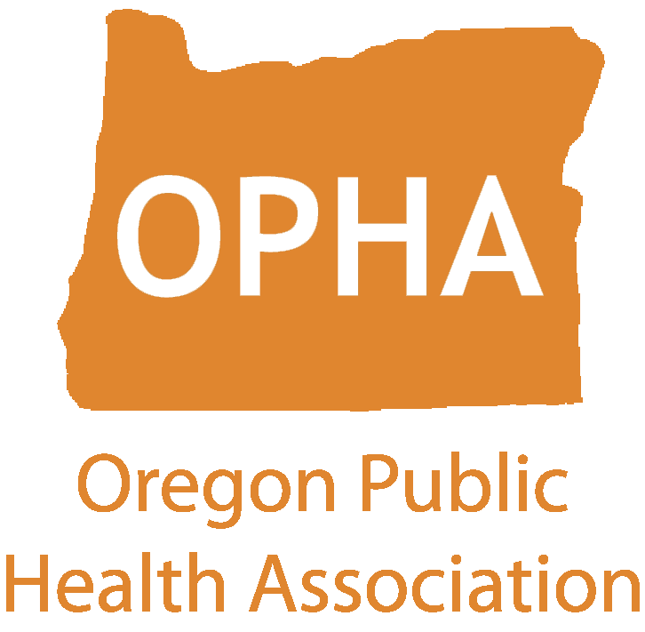
Agenda: Board of Directors Meeting
Friday, April 17th, 2026
10:00 – 12:00 pm
https://us06web.zoom.us/j/89494958453
Passcode: 248490

Attendees: Kim Valdez, Briana Arnold, Heather Daniel, Lillie Manvel, Liz Budd, Debbie Kaufman, Jamie Jones, Megan Cahn, Val Striplin, Audrey Egan, Menolly Kaufman, Madison Riethman, Greg Sebastien, Ma’Adjoa, Jessica Barker, Sarah Andersen, Dustin Daniel

Absent: Laura Daily, Josie Hall, Julie Plagenhoef, Amrita, Alex Salas

10:08: Call to Order (Kim Valdez)

● Welcome ● Shared agreements
○ Bring a growth mindset
○ Assume good Intent
○ Get curious (listen with curiosity and compassion)
○ Lean into discomfort
○ Judgment-free zone
○ Ask for what you need
○ Commit to open two-way communication
○ Own your impact
○ Step up-Step Back

10:13: Board Member Introductions
● Please share your name, pronouns, organization, and your go-to-karaoke song (whether you actually sing or not).

10:25: Approve February & March Minutes - Vote
Kim Valdez makes a motion to approve March minutes, seconded by Lille Manvel. Briana, Megan, Greg, Jessica Barker abstained, none opposed. March minutes approved.

10:35: Executive Director’s Report - Update (Val Striplin)
- Technology & Platforms
  - MemberClicks has been approved, now good to go to use google. Waiting to make sure we can leverage free nonprofit google platform.
  - Zoom account is finally fixed!
  - My outbound emails are landing in junk folders. Until we move everything to go google, please look through your junk email folders for emails from me.
- Board Retreat & Strategic Planning
  - All should be able to do board training ahead of Board retreat.



  - On April 1 I (hopefully) sent an email with Jacobsen’s questionnaire in preparation for strategic planning
  - Please let Val know as soon as possible if you need hotel accommodations for board retreat.
(Madison, Jessica Barker, Briana Arnold, Ma’Adjoa have had challenges accessing the board training document.)
- Section Governance – Debbie Kaufman
  - Laura, Debbie and I met and are working on this, created google drive for this. Debbie has offered to facilitate and bring together section leaders to develop cohesion around meetings.
  - Students reach out to me regularly about starting a student section. Folks from Oral hygiene section wants to re-engage as well.
- NPHW Recap
  - Not trying to flood emails, increased engagement on LinkedIn, people have reached out and want to engage OPHA. OHSU-PSU School of Public Health sharing events, next year will really lean into that. Kudos to Heather for doing member spotlight, 16-17 members responded to call outs.
Greg Sebastien: Elisabeth was working to create student section for college and HS students, HS student in Portland showed interest (Meikai Gardner). For any student under 18, we should consider additional training for board members.
Debbie Kaufman: I am trying to make sure I have all email addresses and names for all Section leadership. If you are chair or rep, please email me your contact information. Debbie@bodyliberationforpublichealth.com
- Partner Outreach & Visibility
  - I’ve had great conversations with leaders and folks want to engage with us. My focus is on rebuilding partnerships, trying to be aware of the position OPHA is in and get us to a solid place. Eventually I will be asking for money.
  - I had a great conversation w/Grandparents For Vaccines. They have national and statewide presence, being able to share what life was like before vaccines were available. They want to speak at conference.
  - Engaging in policy talks w/APHA
- Conference Planning
○ Contract has been signed; venue has been paid. Conf planning committee has met twice an we have solid list of candidates to bring to board. I do have the form that Conf planning committee put in rank choice.
- Keynote Speaker Finalists – Board Review
- I will be sending list to board members to vote on. Call for abstracts will go out next week
- Sarah Andersen: our campaign to get sponsors for conference is open. All should have received an invite in google sheets, asking all board members to reach out to 5 organizations. Development Committee setting up times for working sessions for folks to do sponsorship asks. First meeting time is April 27 at 3 p.m. and the second work session is on 4/29 at 5:30 p.m
Vote to Confirm Menolly Kauffman as Conference Planning Committee Chair
  - Kim asks board to hold off on vote, asks Menolly to submit statement of interest and we can do email vote.

11:00: Section Updates (Section Representatives)
Weight Inclusive Health Section (Liz Budd): planning section only meeting in May. Excited to have Mayan from WSHD presenting on recommendations on doing epidemiology in Weight inclusive ways. I am section counselor in APHA, we’ll be doing presentation for APHA in July on how to conduct weight inclusive physical activity research and practice.
Food and Nutrition Section (Dustin Daniel): no updates
Epi-Biostats Section (Madison Reithman): working out tech issues, switching from google meet to diff platform, focused on scholarships for OPHA conference. Planning to do informal get together for section members for this summer
Disability Section: (not present)
Nursing Section: (not present)
Healthy Environments: Greg Sebastien says Section member has expressed in being co-chair and hoping to get confirmed through vote of Section members. Great transition of leadership as ive been in this role 3 years now. I am happy to support Laura and Debbie on Section work. Discussing early summer webinar on water environment in rural vs urban and algae blooms. Working with Briana Arnold to do webinar later this year. Support scholarships for OPHA members.

11:20: Discussing Board Roles/Committees (Kim Valdez)
Kim Valdez reviews various OPHA Committees (attached)
Sarah Andersen asks Kim how do board members express interest in being in a particular committee?
Briana Arnold wants to know when we’ll ask people to join nomination committee
Kim: EC having this discussion right now. Briana and Kathleen Carlson who are our 2 members in noms committee. Kathleen came on in 2025, could use 1 more person after Wyn’s resignation.
Kim Valdez: at board retreat, we’ll share more more about committees and look to recruit board members to participate.
11:45: Policy Committee (Julie Reeder)

12:00 Adjourn

Upcoming Board Meeting: Friday, May 15, 2026, 10 am - 12 pm PST – BOD Retreat in Lieu of Board Meeting

