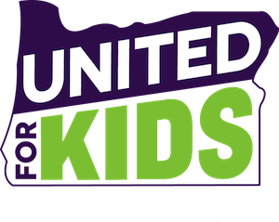

Gov. Kate Brown
Sen. Richard Devlin, Co-Chair, Ways and Means Committee
Rep. Nancy Nathanson, Co-Chair, Ways and Means Committee
Sen. Mark Hass, Chair, Senate Finance and Revenue Committee
Rep. Phil Barnhart, Chair, House Revenue Committee

Dear Governor, Senators, and Representatives,

United for Kids advocates represent over 100 organizations and coalitions that work together to make Oregon the “Best Place to be a Kid.” Our individual and collective work to improve the economic security, education, health, and safety of the state’s 860,000 children stand at the center of our efforts. Today, we ask you to join us in making Oregon’s kids, and the programs and services that support them, your priority as well.

The challenges the state’s budget poses to children are real:
- Foster youth suffer from inadequate staffing and training in Child Welfare.
- Over 200,000 children are food insecure.
- Over 17,000 low-income children are uninsured.
- Oregon has the third largest class sizes in the nation.
- Over 20,000 kids in Oregon school districts are homeless.
- Home visiting reaches only 15% of families who most need it.
- Children of color and those living in rural Oregon receive disparate services.
- Over 350,000 Oregon children live at or near poverty.

Current service levels are inadequate to meet the needs of children. Kids need to see improvements in all areas. We know you understand that the return on investments in children reap rewards for decades to come. These investments must be made now – this session – so that we can stop consigning our children to a mediocre future.

We, the undersigned members of United for Kids, urge you to raise revenue now – not just to balance the budget, but to make the robust commitment of resources necessary to move the needle for kids. We pledge to support you in this effort.

On behalf of Oregon’s children and their families, thank you.

